Guidelines to format your thesis
The thesis should be printed following these instructions. You have to use the green cover that is available upon request by the administration offices.

The external dimensions are 24 cm (h) and 16.5 cm (w). The front and back covers thus allow a volume of max ca. 110 pages (220 if printed rear and front) of standard paper sheets (ca. 80 g/m²). In case you have more pages, just divide the cover into 2 parts and use an additional border for the side.

The text pages should have the final following borders:

- Top: 1.70 cm
- Bottom: 1.70 cm
- Left: 2.50 cm
- Right: 1.70 cm

The margins options can be accessed going to Layout-Margins-Custom Margins (see the figure below):
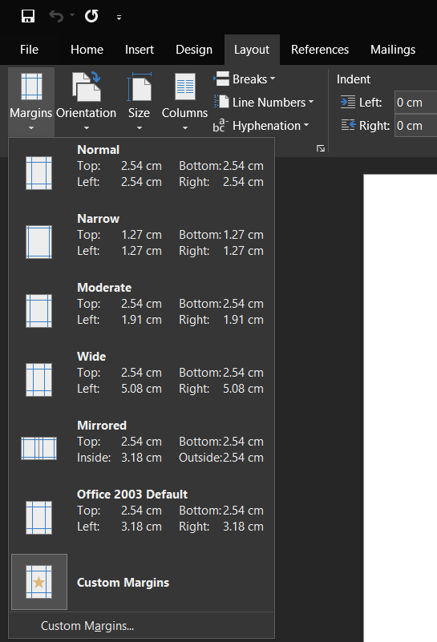
As we assume that you will use A4 (21 x 29,7 cm) paper sheets for printing, to have the final size, use the following layout. (see the figure below):

- Top: 1.70 cm
- Bottom: 7.40 cm
- Left: 2.50 cm
- Right: 6.00 cm
- Gutter: 0.00 cm

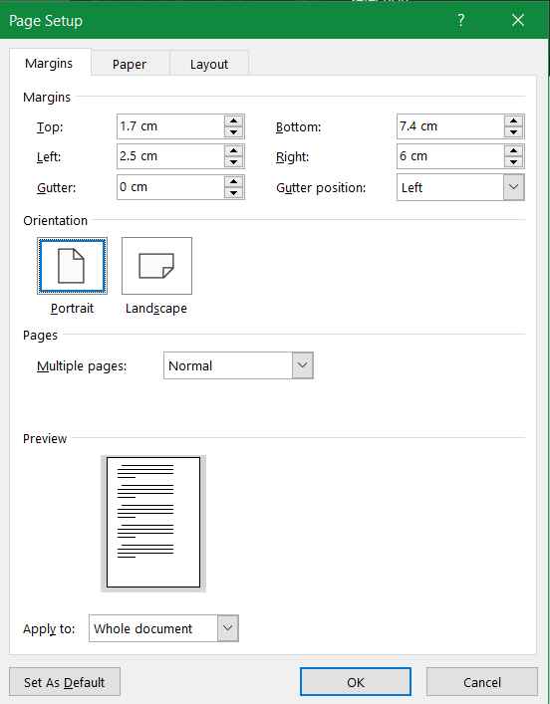

- Distance from the lower border (footer): 6.30 cm (this will allow you to get the page numbers in the correct position). Move to Layout tab (see the figure below):
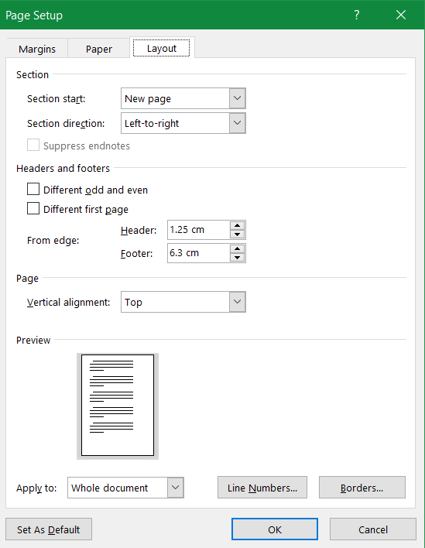

As, typically, you will print with the front/rear option, we suggest to use the “coupled” pages option. In that case, the margins are as shown in the figure. The same margin options can be accessing from print menu:
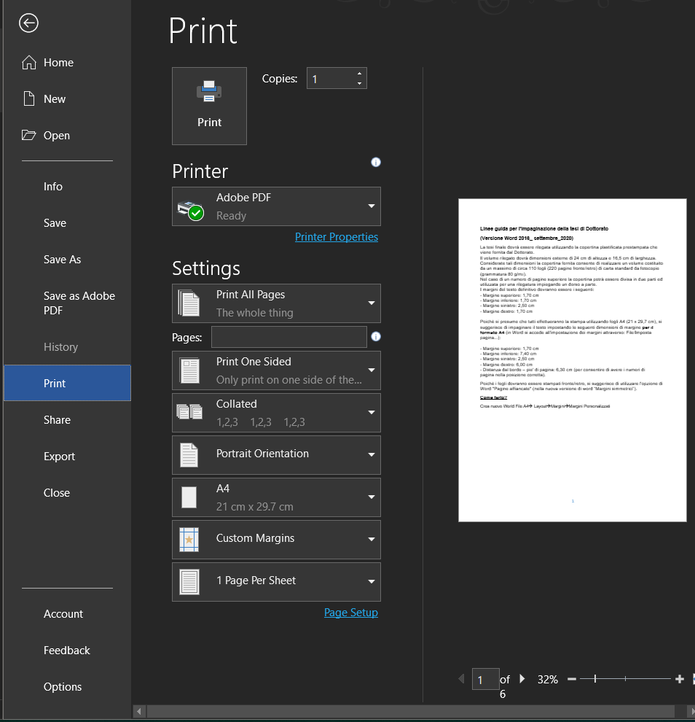
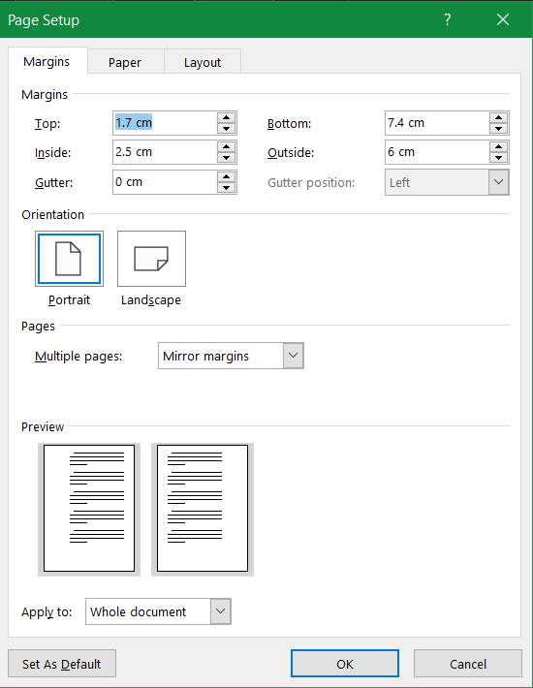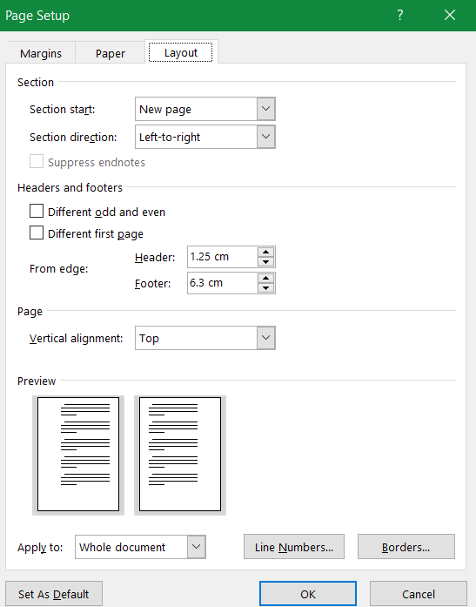

The paragraphs of thesis should follow this format:

- "Times New Roman" or "Arial" (as you like);
- Size 12 or 11
- Single or 1.5 space. No double space. You can leave some space between paragraphs (e.g. 6).
- Justify your text
- No special formatting (first line etc..).
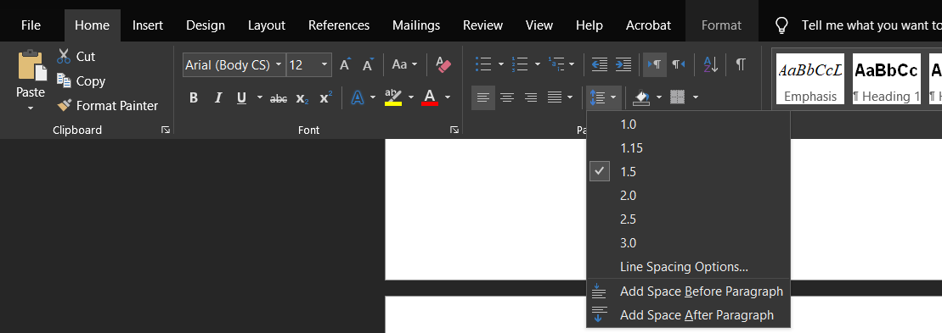

We suggest using the same type of character for titles and for text body. Please avoid using sizes bigger than 16 pts.
If you follow the above described instructions, your thesis should look like the example reported below.

Front page
To prepare your front page, use the Word template Modello_frontespizio.doc. The template was prepared with the right margins and already has some logos and important information. Change the language if you write in English and insert the appropriate information about cycle, name etc…
The green front cover has a window allowing to show the thesis title and the name of the PhD candidate. Pay attention that your name and thesis title are within the frame which is visible by activating the formatting symbols as shown in the picture below. You can activate it by pressing the ¶ symbol in the standard tools bar. The frame will not be present in the printed copy.

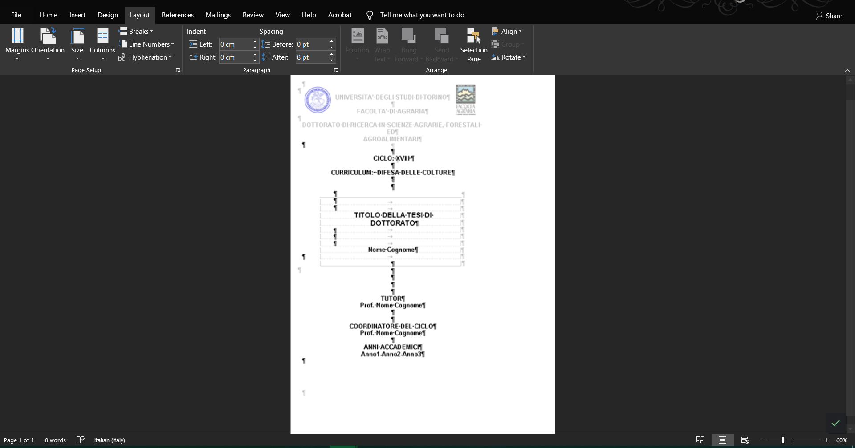
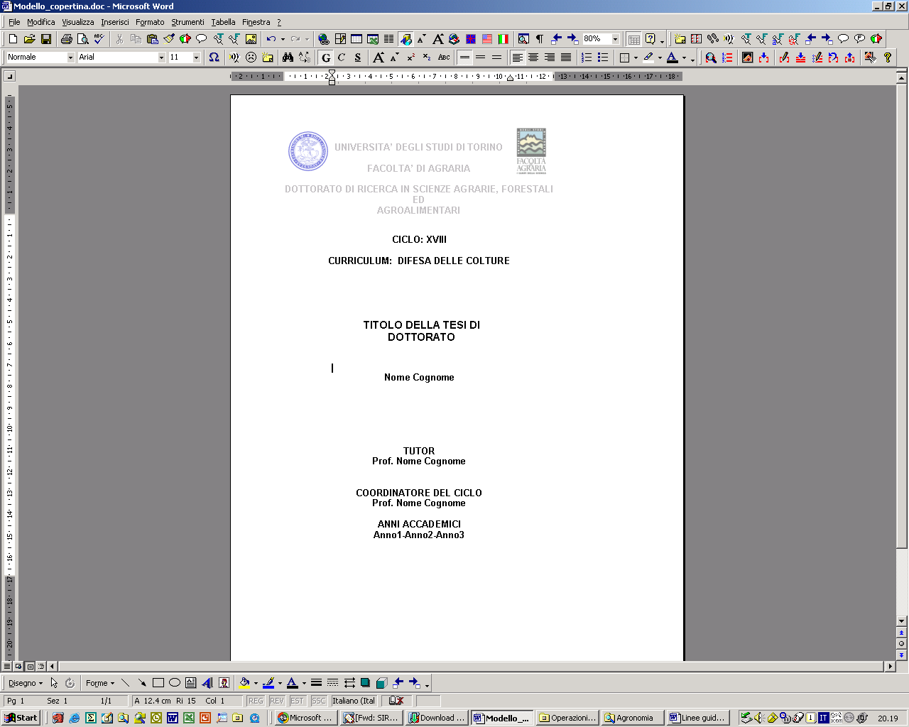

IMPORTANT!!
If your thesis is a collection of published papers, you MUST be sure that you have all necessary authorizations from the publishers. Quite often you are not allowed to use the editorial pdf but only a pre-print copy, with full citation to the published version.
You may get additional information about publishers’ policies at
http://www.sherpa.ac.uk/romeo/

